Hough_Grd(imgfltrd, 8, 0.4); Hough_Grd(imgfltrd, 8, 0.3);

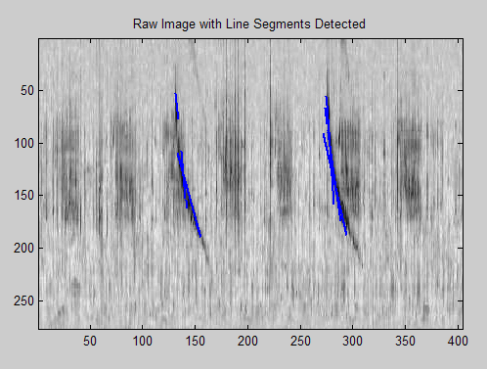 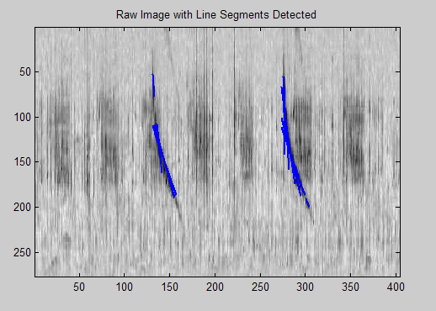

Hough_Grd(imgfltrd, 8, 0.2);

